

**Assignment 1**

**Name : Shumaila Munsib**

**Roll No: 2023-BSE-062**

**Submitted To: Sir Waqas Saleem**

**Task 1:**

Run Gitea in Codespace and Created an Initial Repo:

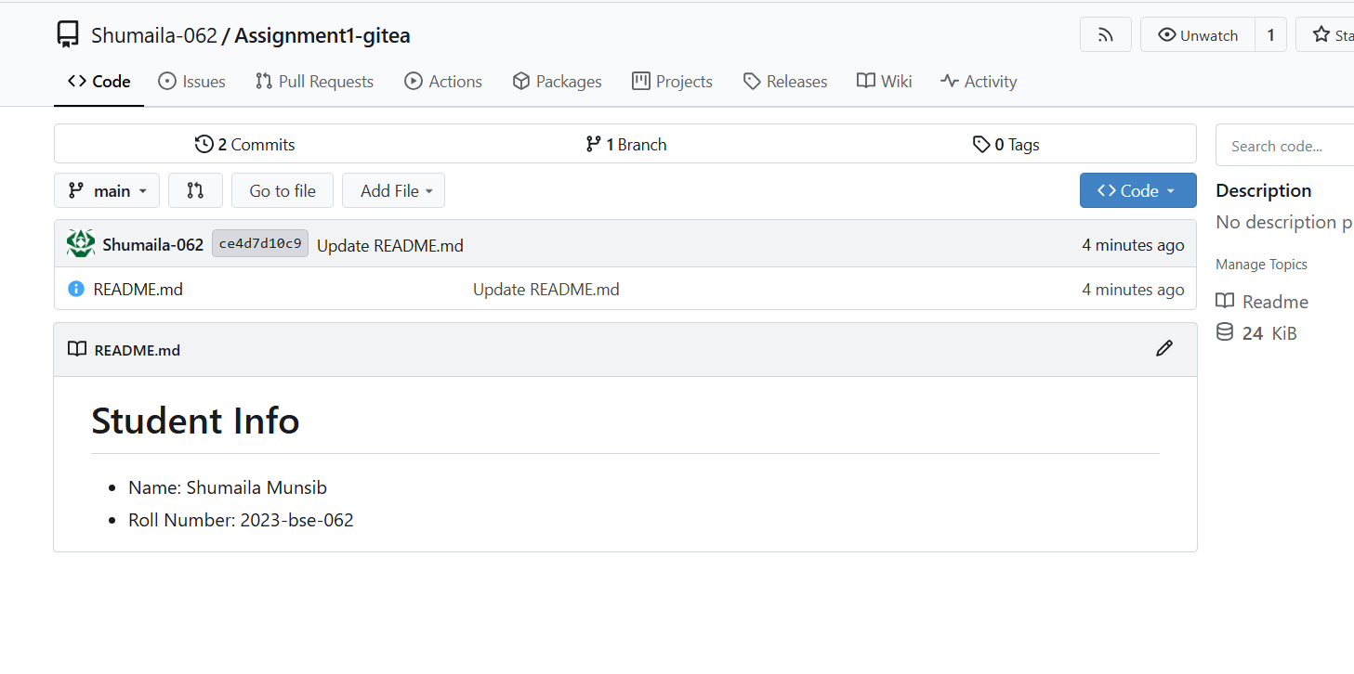

**Task 2:**

Copying readme from gitea to github repository:

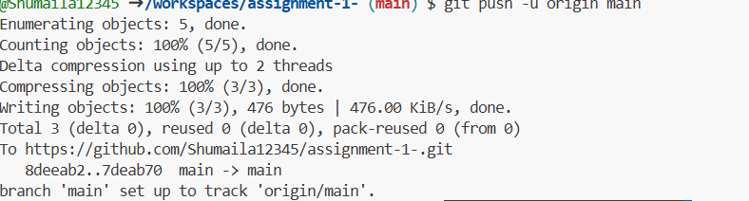

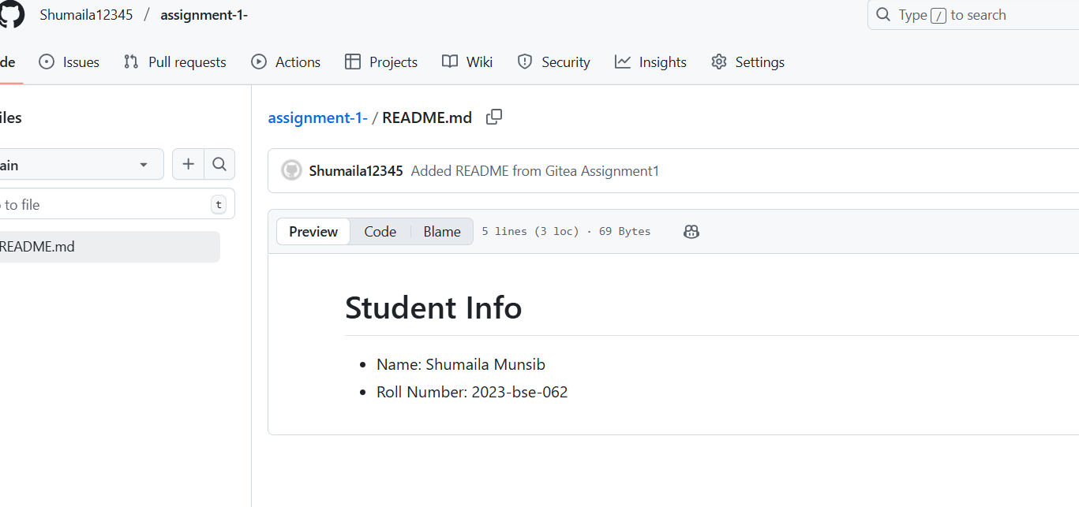

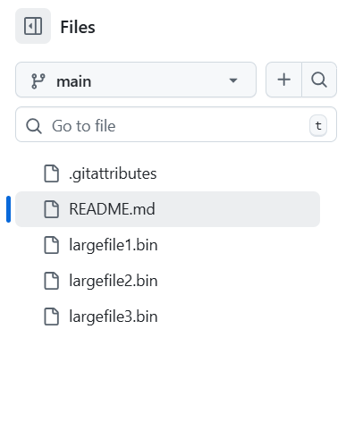

**https://github.com/Shumaila12345/assignment-1-.git**

**Task 3:**

Output of command git remote -v:

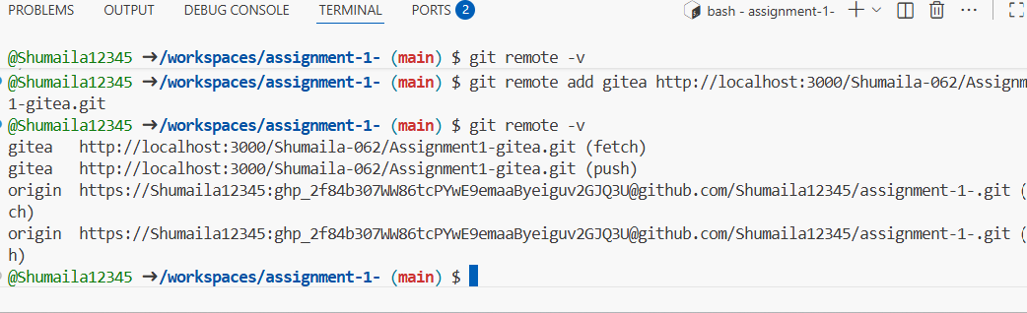

**Task 4:**

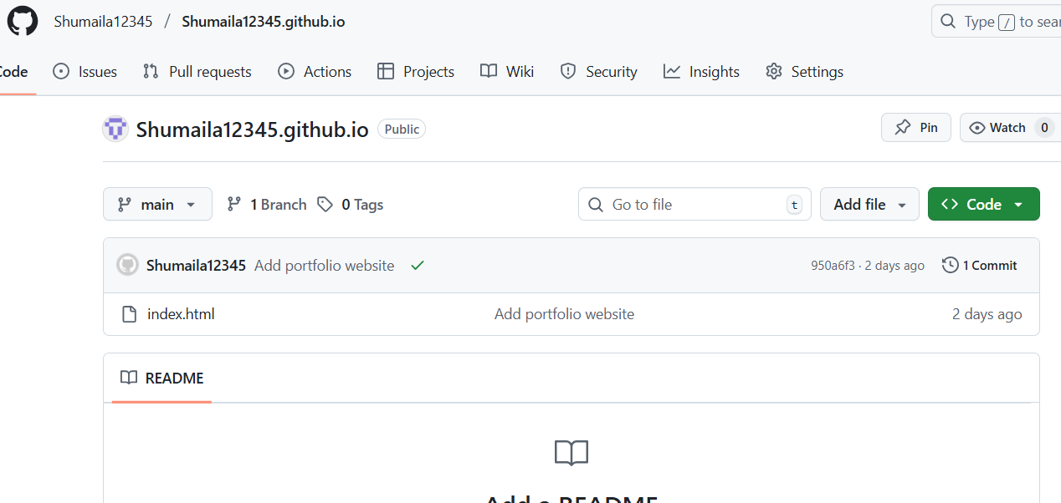

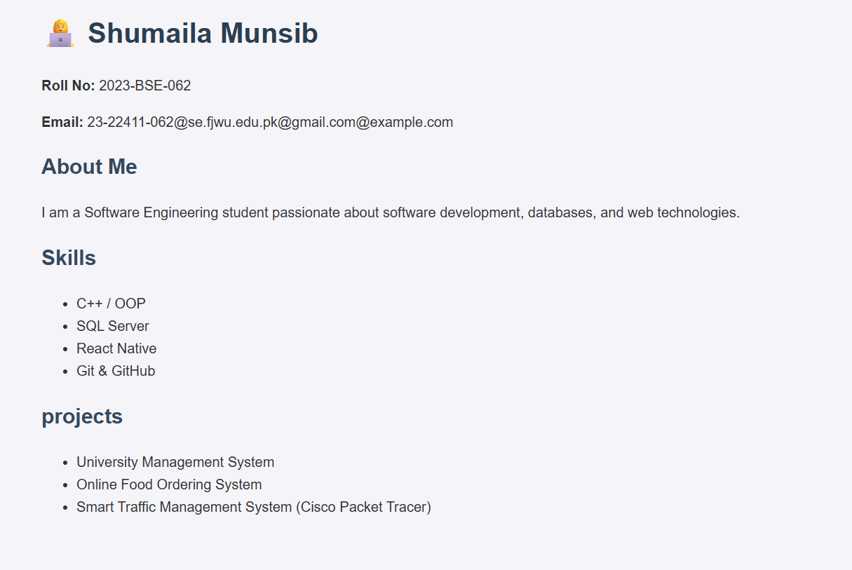

[**https://Shumaila12345.github.io**](https://Shumaila12345.github.io)